PETITE DANCE CAMP WITH KELSI BEALS
DATES: JULY 15th, 17th, 22nd, 24th, 29th & 31st
TIME: 5:30-6:30
LOCATION:
Spirit of Dance
179 S. Algoma St., 2nd Floor
(807) 623-4789
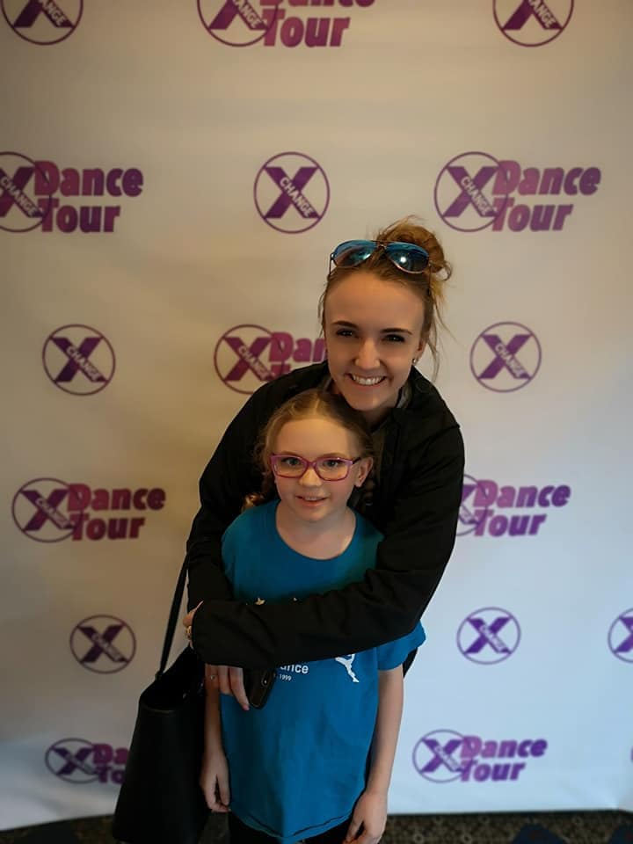
Join Kelsi Beals, for this three week mini session designed for Petite dancers. Young dancers will work on both jazz and ballet technique, while learning energetic choreography! Great for students to try out classes before committing to a full year or for students to continue developing their dance technique. This camp is designed for ages 4-7 years.

Kelsi has been an active member of the Thunder Bay Dance Community for 15 years. Kelsi has had the privilege of dancing on many stages including at Walt Disney World’s Magic Kingdom, Florida, Minneapolis, Chicago, Nassau, Bahamas and Houston, Texas to name a few. She is devoted to the development of young dancers and loves passing on her knowledge to them.

---------------------------------------------------------------------------------------------------------------------Student Name:________________________________________ Age:________ D.O.B:__________________ Address: ______________________________________Postal Code:__________ Phone:_____________ Cell: _________________
$60/6 sessions

Payment: $ ______ (cash, cheque, debit, visa or mc) DATE OF PAYMENT: ______________
Waiver of Release: We, the staff at Spirit of Dance studio, recognize our obligation to ensure our students and their parents/guardians are aware of the risks and hazards involved in dance education. By signing this waiver, you release Spirit of Dance and all its employees, contractors and volunteers from all claims on account of any injury which may be sustained by your child while attending any dance class/workshop associated with Spirit of Dance and/or Tim Olson. In signing this waiver, you also acknowledge your responsibility in paying all communicated costs involved.
Parent’s Signature ____________________________ Date ___________
PHOTO RELEASE: By initialing here, I give permission for photographs of my child in dance class or performances to be used in promotional material for Spirit of Dance and/or Tim Olson, in both print and web publications. __________

